SAFETY DATA SHEET
OSHA HCS (29 CFR 1910.1200)

SECTION 1: PRODUCT AND COMPANY IDENTIFICATION
Product identifier
 | Chemical Name | Mixture
 | CAS No. | Mixture
 | Trade Name | CORE SPRAY GLUE
 | Product Code | M-5575
Relevant identified uses of the substance or mixture and uses advised against
 | Identified Use(s) | Adhesive Product
 | Uses Advised Against | None
 | Company Identification | Spray Products Corporation  P.O. Box 737  Norristown, PA 19404
 | Telephone | (610) 277-1010
 | Fax | (610) 277-4390
 | E-Mail (competent person) | johnd@sprayproducts.com
Emergency telephone number
 | Emergency Phone No. | Transportation Emergency: CHEMTREC 24 hr. 1-800-424-9300 / 1 (703) 527-3887 (Collect calls accepted)

SECTION 2: HAZARDS IDENTIFICATION
Classification of the substance or mixture
 | OSHA HCS (29 CFR 1910.1200) | Flam. Aerosol 1; Liquefied gas; Eye Irrit. 2; Skin Irrit. 2; Repr. 2; STOT SE 3; STOT RE 2; Asp. Tox. 1
Label elements
 | Hazard Symbol | 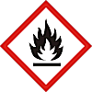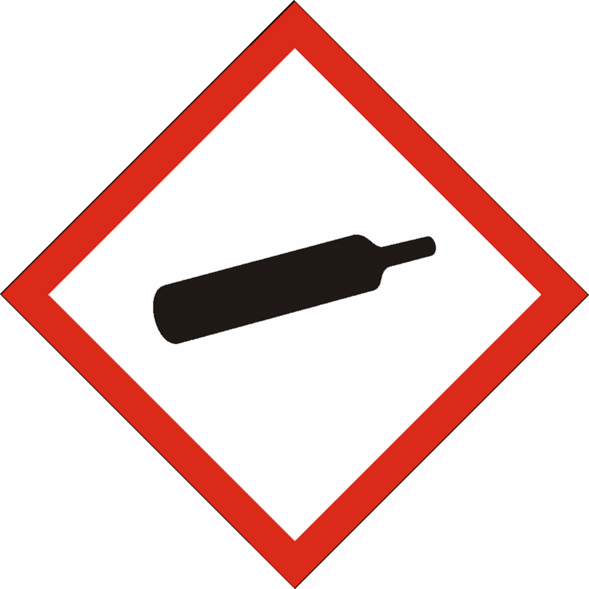
 | Signal word(s) | DANGER
 | Hazard Statement(s) | Extremely flammable aerosol.  Contains gas under pressure; may explode if heated.  Causes serious eye irritation.  Causes skin irritation.  Suspected of damaging fertility or the unborn child.  May cause damage to organs through prolonged or repeated exposure: Central Nervous System, Route: Inhalation  May cause drowsiness or dizziness.  May be fatal if swallowed and enters airways.
 | Precautionary Statement(s) | Obtain special instructions before use.  Do not handle until all safety precautions have been read and understood.  Keep away from heat/sparks/open flames/hot surfaces. – No smoking.  Do not spray on an open flame or other ignition source.  Do not pierce or burn, even after use.  Avoid breathing spray.  Wear protective gloves/eye protection.  Wash hands and exposed skin after use.  Use only outdoors or in a well-ventilated area.  Protect from sunlight and do not expose to temperatures exceeding 50 ºC/122 ºF.
Other hazards |  | None

SECTION 3: COMPOSITION/INFORMATION ON INGREDIENTS
Hazardous Ingredient(s) | % wt. * | CAS No. | Hazard classification
n-Hexane | 25 - 30 | 110-54-3 | Flam. Liq. 2; H225  Asp. Tox. 1; H304  Repr. 2; H361  Skin Irrit. 2; H315  STOT SE 3; H336  STOT RE 2; H373
Acetone | 25 - 30 | 67-64-1 | Flam. Liq. 2; H225  Eye Irrit. 2; H319  STOT SE 3; H336
Propane | 20 - 30 | 74-98-6 | Flam. Gas 1; H220  Liquefied gas; H280

Additional Information - None
* The exact percentage withheld as a trade secret in accordance with 29 CFR 1910.1200.

SECTION 4: FIRST AID MEASURES
Description of first aid measures
 | Inhalation |  | Remove person to fresh air and keep comfortable for breathing. If breathing is labored, administer oxygen. If symptoms develop, obtain medical attention.
 | Skin Contact |  | Wash affected skin with soap and water. If skin irritation occurs, get medical advice/attention. Take off contaminated clothing and wash it before reuse.
 | Eye Contact |  | Rinse cautiously with water for several minutes. Remove contact lenses, if present and easy to do. Continue rinsing. Get medical attention if eye irritation develops or persists.
 | Ingestion |  | Do not give anything by mouth to an unconscious person. Do NOT induce vomiting. Get medical attention immediately.
Most important symptoms and effects, both acute and delayed |  |  | Aspiration of droplets may cause pulmonary oedema.
Indication of any immediate medical attention and special treatment needed |  |  | IF SWALLOWED: Immediately call a POISON CENTER or doctor/physician.

SECTION 5: FIRE-FIGHTING MEASURES
Extinguishing Media
-Suitable Extinguishing Media |  | Extinguish with carbon dioxide, dry chemical, foam or water spray.
-Unsuitable Extinguishing Media |  | Do not use water jet.
Special hazards arising from the substance or mixture |  | Highly flammable vapor (flash point below 23°C).
Advice for fire-fighters |  | A self contained breathing apparatus and suitable protective clothing should be worn in fire conditions. Keep containers cool by spraying with water if exposed to fire.

SECTION 6: ACCIDENTAL RELEASE MEASURES
Personal precautions, protective equipment and emergency procedures | Keep away from heat/sparks/open flames/hot surfaces. – No smoking. Avoid contact with skin and eyes. Avoid breathing spray. Wear protective gloves/eye protection.
Environmental precautions | Prevent liquid entering sewers, basements and work pits.
Methods and material for containment and cleaning up | Cover spills with inert absorbent material. Transfer to a container for disposal or recovery.
Reference to other sections | None
Additional Information | None

SECTION 7: HANDLING AND STORAGE
Precautions for safe handling | Keep away from heat/sparks/open flames/hot surfaces. – No smoking. Avoid contact with skin and eyes. Use product in a well-ventilated area only. Avoid breathing spray.
Conditions for safe storage, including any incompatibilities
-Storage temperature | Keep in a cool, well ventilated place. Protect from sunlight. Store at temperatures not exceeding 50 °C / 122 °F. Keep container tightly closed.
-Incompatible materials | This product should be stored away from sources of strong heat and oxidizing chemicals. Also avoid: acids, bases, reducing agents, peroxides, amines, ammonia, chlorine and halogens.
Specific end use(s) | Adhesive Product

SECTION 8: EXPOSURE CONTROLS/PERSONAL PROTECTION
Occupational Exposure Limits
SUBSTANCE. | CAS No. | (8hr TWA) |  | (STEL) |  | Note:
 |  | PEL  (OSHA) | TLV  (ACGIH) | PEL  (OSHA) | TLV (ACGIH)
Hexane | 110-54-3 | 500 ppm | 50 ppm* | ----- | ----- | *Skin
Acetone | 67-64-1 | 1000 | 500 | ------ | 750 | ^NIC
Propane | 74-98-6 | 1000 ppm | Aspyx.# | ----- | ----- | #
^NIC = Notice of Intended Changes (ACGIH®); #Assure minimum oxygen content of work atmosphere.
Recommended monitoring method |  | NIOSH 1500 (hydrocarbons, B.P. 36 - 126 ºC); NIOSH 1300 (Ketones I).
Exposure controls
Appropriate engineering controls |  |  |  | Provide adequate ventilation to ensure that the occupational exposure limit is not exceeded.
Personal protection equipment
 | Eye/face protection |  |  | Wear protective eyewear (goggles, face shield, or safety glasses).
 | Skin protection (Hand protection/ Other) |  |  | Wear suitable gloves if prolonged skin contact is likely. Check with protective equipment manufacturer's data.
 | Respiratory protection |  |  | Normally no personal respiratory protection is necessary. In case of insufficient ventilation, wear suitable respiratory equipment. Check with protective equipment manufacturer's data.
 | Thermal hazards |  |  | Not normally required. Use gloves with insulation for thermal protection, when needed.
Environmental Exposure Controls |  |  |  | None known

SECTION 9: PHYSICAL AND CHEMICAL PROPERTIES
Information on basic physical and chemical properties
Appearance | Aerosol spray
Color. | Colorless
Odor | Not available
Odor Threshold (ppm) | Not available
pH (Value) | Not available
Melting Point (°C) / Freezing Point (°C) | Not available
Boiling point/boiling range (°C): | Not available
Flash Point (°C) | -104 (Propane)
Evaporation Rate | Not available
Flammability (solid, gas) | Extremely flammable aerosol.
Explosive Limit Ranges | 2.1% - 9.5% v/v (Propane)
Vapor pressure (Pascal) | ca. 95 x 10⁴ (Propane)
Vapor Density (Air=1) | ca. 1.56 @ 0ºC (Propane)
Density (g/ml) | Not available
Solubility (Water) | Not available
Solubility (Other) | Not available
Partition Coefficient (n-Octanol/water) | Not available
Auto Ignition Point (°C) | 450 (Propane)
Decomposition Temperature (°C) | Not available
Kinematic Viscosity cSt | <20.5 @ 40°C
Explosive properties | Not explosive.
Oxidizing properties | Not oxidizing.
Other information | Not available

SECTION 10: STABILITY AND REACTIVITY
Reactivity | Stable under normal conditions.
Chemical stability | Stable.
Possibility of hazardous reactions | None anticipated.
Conditions to avoid | Avoid contact with heat and ignition sources.
Incompatible materials | This product should be stored away from sources of strong heat and oxidizing chemicals. Also avoid: acids, bases, reducing agents, peroxides, amines, ammonia, chlorine and halogens.
Hazardous decomposition product(s) | Forms carbon oxides under fire conditions.

SECTION 11: TOXICOLOGICAL INFORMATION
Exposure routes: Inhalation, Skin Contact, Eye Contact

Information on toxicological effects
n-Hexane (CAS No. 110-54-3):
Acute toxicity | Oral: LD50 ≈16 g/kg-bw (May be fatal if swallowed and enters airways.)  Dermal: LD50 >2 g/kg-bw. rabbit  Inhalation: LC50 > 17600 mg/m3 (Vapor), 24-hr. rat (May cause drowsiness or dizziness.)
Irritation/Corrosivity | Causes skin irritation. Repeated exposure may cause skin dryness or cracking.
Sensitization | It is not a skin sensitizer.
Repeated dose toxicity | LOAEL: 37973 mg/kg (101 days, oral, rat, CNS effects)  NOAEL: 1135 mg/kg (101 days, oral, rat, CNS effects)  NOAEC: 1760 mg/m3 (90 day, inhal., female mice, nasal lesions)  LOAEC: 3000 ppm (12 hr a day for 16 weeks, inhal., rat, CNS effects
Carcinogenicity (By analogy with similar materials) | NOEL: 31736 mg/m3 (2 years, inhal. Oncogenic effects)
NTP | IARC | ACGIH | OSHA | NIOSH
No. | No. | No. | No. | No.

Mutagenicity | There is no evidence of mutagenic potential.
Reproductive toxicity | Studies in animals have shown that repeated exposures produce adverse reproductive effects.
Acetone (CAS No. 67-64-1):
Acute toxicity | Oral LD50 = 5800 mg/kg (rat)  Dermal LD50 >15800 mg/kg (rabbit)  Inhalation LC50 76 mg/L (4 hour(s)) (rat) - Vapours may cause drowsiness and dizziness.
Irritation / Corrosivity | Causes serious eye irritation. Repeated exposure may cause skin dryness or cracking.
Sensitisation | It is not a skin sensitiser.
Repeated dose toxicity | Oral NOAEL = 900 mg/kg/day (rat) (90-days)  Inhalation NOAEL > 19,000 ppm (rat)
Carcinogenicity | It is unlikely to present a carcinogenic hazard to man.
NTP | IARC | ACGIH | OSHA | NIOSH
No. | No. | No. | No. | No.

Mutagenicity | Negative
Toxicity for reproduction | Negative
Other information | None known.

SECTION 12: ECOLOGICAL INFORMATION

Ecotoxicity
n-Hexane (CAS# 110-54-3):
Short term | LC50 (96 hour): >1000 µg/L (Oryzias latipes)  LC50 (48 hour): 45 mmol/m3 (Daphnia magna, mortality)  EC50 (96 hour): 2.66% (C. pyreniodosa)
Long Term | NOELR (28 days) 2.8 mg/l (Fish) QSAR  NOELR (21 days): 4.88 mg/l (Daphnia magna) QSAR  NOEL (96 hour) 2.077 mg/l (Algae) QSAR
Acetone (CAS No. 67-64-1):
Short term | LC50 (96 hour): 5,540 mg/l (Rainbow Trout (Oncorhynchus mykiss))  LC50 (96 hour): 8,300 mg/l (Bluegill Sunfish (Lepomis macrochirus))  LC50 (48 hour(s)): 12,600 – 12,700 mg/l (Daphnia magna)  EC50 (14 d): 3,020 mg/l (Algae (Chlorella pyrenoidosa)  EC50 (15 min): 14,500 mg/l (Bacteria (Photobacterium phosphoreum)
Long Term | Not available.
Persistence and degradability | Readily biodegradable.
Bioaccumulative potential | Not available.
Mobility in soil | Not available.
Results of PBT and vPvB assessment | Not available.
Other adverse effects | None known.

SECTION 13: DISPOSAL CONSIDERATIONS
Waste treatment methods | Disposal should be in accordance with local, state or national legislation. Consult an accredited waste disposal contractor or the local authority for advice.

SECTION 14: TRANSPORT INFORMATION
 | U.S. DOT | Sea transport  (IMDG) | Air transport (ICAO/IATA)
UN number | 1950 | 1950 | 1950
Proper Shipping Name | Aerosols, flammable | Aerosols, flammable | Aerosols, flammable
Transport hazard class(es) | 2.1 | 2.1 | 2.1
Packing group | Not applicable | Not applicable | Not applicable
Environmental hazards | None assigned | None assigned | None assigned
Special precautions for user | None assigned | None assigned | None assigned
Transport in bulk according to Annex II of MARPOL73/78 and the IBC Code: Not applicable

SECTION 15: REGULATORY INFORMATION
Safety, health and environmental regulations/legislation specific for the substance or mixture:
TSCA (Toxic Substance Control Act) - Inventory Status: All components listed or polymer exempt.
Designated Hazardous Substances and Reportable Quantities (40 CFR 302.4):
 |  |  | Chemical Name | CAS No. |  |  | Typical %wt. |  |  |  | RQ (Pounds)
 |  |  | n-Hexane | 110-54-3 |  |  | ~28 |  |  |  | 5000
 |  |  | Acetone | 67-64-1 |  |  | ~27 |  |  |  | 5000
SARA 311/312 - Hazard Categories:
 | Fire Sudden Release Reactivity Immediate (acute) Chronic (delayed)
SARA 313 - Toxic Chemicals (40 CFR 372):
 |  |  | Chemical Name |  |  |  |  | CAS No. |  |  |  |  | Typical %wt.
 |  |  | n-Hexane |  |  |  |  | 110-54-3 |  |  |  |  | ~28
SARA 302 - Extremely Hazardous Substances(40 CFR 355):
 |  |  | Chemical Name |  |  | CAS No. |  |  |  | Typical %wt. |  | TPQ (pounds)
 |  |  | None |  |  | ---- |  |  |  | ---- |  | ----
California Proposition 65 List:
 |  | Chemical Name |  |  | CAS No. |  |  |  | Type of Toxicity
 |  | Benzene* |  |  | 71-43-2 |  |  |  | Cancer; Developmental
 |  | Methanol* |  |  | 67-56-1 |  |  |  | Developmental
 |  | *Trace to none

SECTION 16: OTHER INFORMATION
The following sections contain revisions or new statements: 1-16.
Date of preparation: March 7, 2015
Hazard Statement(s) and Risk Phrases Listed in: SECTION 2:/ SECTION 3:
Hazard Statement(s)
- H220: Extremely flammable gas.
- H222: Extremely flammable aerosol.
- H225: Highly flammable liquid and vapor.
- H280: Contains gas under pressure; may explode if heated.
- H304: May be fatal if swallowed and enters airways.
- H315: Causes skin irritation.
- H319: Causes serious eye irritation.
- H336: May cause drowsiness or dizziness.
- H361: Suspected of damaging fertility or the unborn child.
- H373: May cause damage to organs through prolonged or repeated exposure.

Training advice: None.
Disclaimer: We believe the statements, technical information and recommendations contained herein are reliable, but they are given without warranty or guarantee of any kind. The information contained in this document applies to this specific material as supplied. It may not be valid for this material if it is used in combination with any other materials. It is the user’s responsibility to satisfy oneself as to the suitability and completeness of this information for the user’s own particular use.

